Ideation Phase
Define the Problem Statements

Date | 18 June 2026
Team ID
Project Name | SHOPEZ : E-Commerce Application
Maximum Marks | 2 Marks

Customer Problem Statement Template:
Create a problem statement to understand your customer's point of view. The Customer Problem Statement template helps you focus on what matters to create experiences people will love.
A well-articulated customer problem statement allows you and your team to find the ideal solution for the challenges your customers face. Throughout the process, you’ll also be able to empathize with your customers, which helps you better understand how they perceive your product or service.
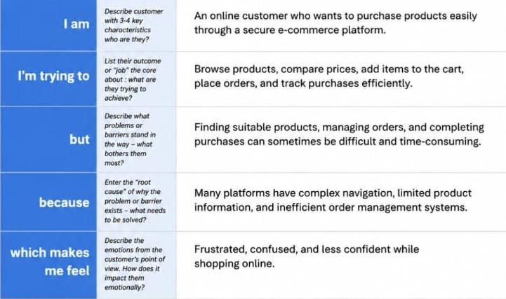
Reference: https://miro.com/templates/customer-problem-statement/

Example:
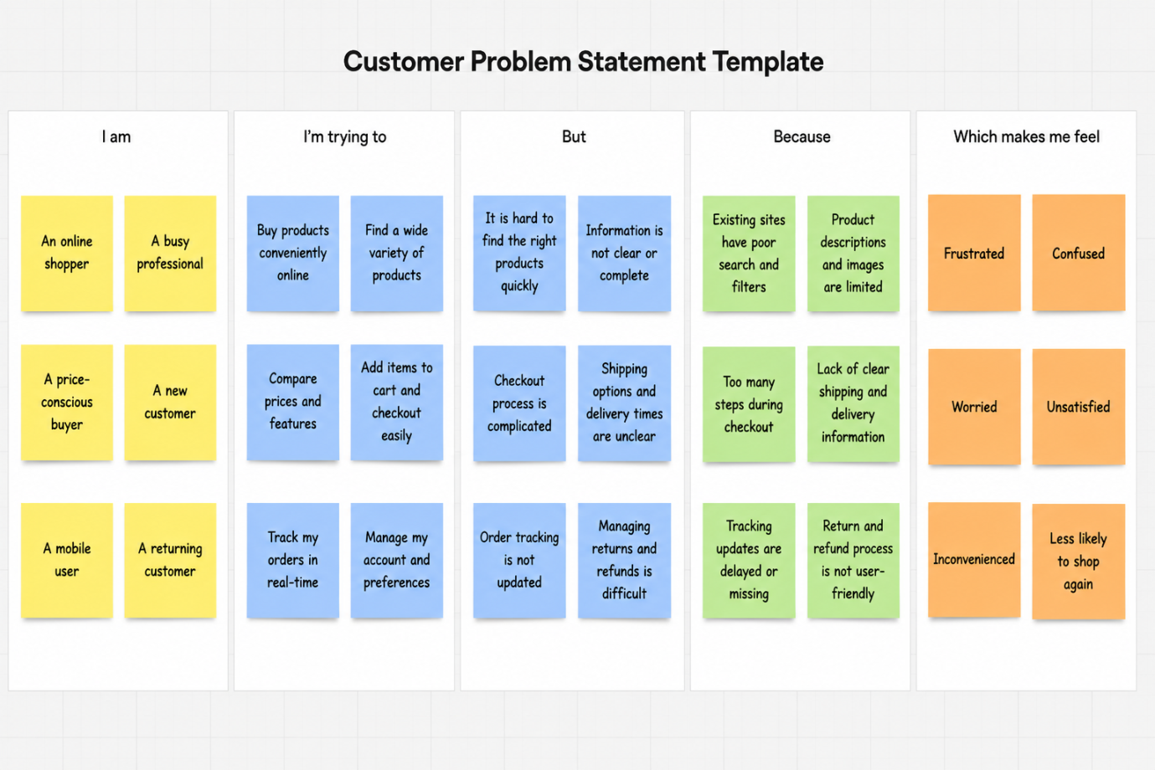
Problem Statement (PS) | I am (Customer) | I’m trying to | But | Because | Which makes me feel
PS-1 | An online shopper | Purchase products conveniently through an online platform | Finding products, comparing options, and managing purchases can be difficult and time-consuming | Existing platforms may have poor navigation, limited information, or complicated checkout processes | Frustrated and dissatisfied
PS-2 | An online shopper | Track orders and manage my purchase history efficiently | It is difficult to monitor orders and access previous purchase details | Order tracking and history management features are not always centralized and user-friendly | Confused and inconvenienced

